**Calculate Total Sales for Each Order**.

db.orders.aggregate([

{

$unwind: "$products"

},

{

$group: {

_id: "$_id",

customer_name: { $first: "$customer_name" },

total_sales: { $sum: { $multiply: ["$products.price", "$products.quantity"] } }

}

}

])

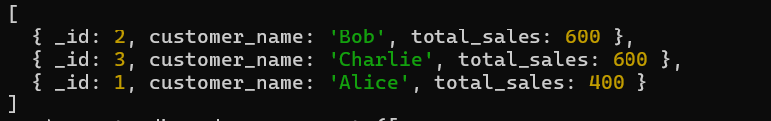

**Calculate Average Order Value for Completed Orders.**

db.orders.aggregate([

{

$match: { status: "Completed" }

},

{

$unwind: "$products"

}, {

$group: {

_id: "$_id",

total_order_value: { $sum: { $multiply: ["$products.price", "$products.quantity"] } }

}

},

{

$group: {

_id: null,

average_order_value: { $avg: "$total_order_value" }}}])



**Find the Maximum Quantity Sold per Product.**

db.orders.aggregate([

{ $unwind: "$products" },

{

$group: {

_id: "$products.product_id",

max_quantity: { $max: "$products.quantity" }

}

}

])

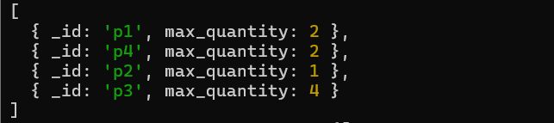

**Find Total Number of Orders for Each Status.**

db.orders.aggregate([

{

$group: {

_id: "$status",

total_orders: { $sum: 1 }

}

}

])



**Calculate Total Quantity of Products Sold Across All Orders.**

db.orders.aggregate([

{ $unwind: "$products" },

{

$group: {

_id: null,

total_quantity: { $sum: "$products.quantity" }

}

}

])



**Get Minimum and Maximum Order Dates.**

db.orders.aggregate([

{

$group: {

_id: null,

min_date: { $min: "$order_date" },

max_date: { $max: "$order_date" }

}

}

])



**Find Total Sales for Each Customer**.

db.orders.aggregate([

{

$unwind: "$products"

},

{

$group: {

_id: "$customer_name",

total_sales: { $sum: { $multiply: ["$products.price", "$products.quantity"] } } }}])



**Calculate the Total Number of Distinct Products Sold**.

db.orders.aggregate([

{ $unwind: "$products" },

{

$group: {

_id: "$products.product_id"

}

},

{

$group: {

_id: null,

distinct_products: { $sum: 1 }

}

}

])

